Wooden Robot Arm

Subject: Physics, Robotics  Related Subjects: Automotive Engineer, Biomedical Engineer, Electrical Engineers,Mechanical Engineer | Grade Level(s):  Length of Lesson: | Type: Project  Keywords: Motion, hydraulic pressure, gravity, control systems, rotation

Lesson Overview

We are now in the age of robotics. From military uses to factory uses to toys, robots have become a part of our life. Since the early days of television and movies, robots have made life easier, saved the world, turned evil and even caused the destruction of the world. To understand robots, we must understand how humans are made. Robots for the most part have been designed to follow human movements.

Lesson Focus
Students will create two robot arms. One will be made from paper and controlled by strings. The other will be made of wood and controlled using hydraulic pressure.

Lesson Objective(s) | By the end of this lesson, students will…  - create a paper robot arm that moves two parts  - create a wooden robot arm that moves two parts and can grab an object.

Lesson Timing

5 minutes | Introduce the Lesson
30 minutes | ...

Materials | - Paper  - Scissors  - String  - Paper clips  - Foam board  - Hot Glue Gun  - Glue sticks  - Plywood  - 1” bolts  - Hex nuts  - Drill  - Drill bits  - Syringes  - Plastic tubing  - Saw  - Scotch or masking tape  - Electrical tape  - Sandpaper  - Craft sticks  - Film canister tops
Instructor Prep | - Step 1
Related Resources | - List related lessons/ppts etc available from USC or outside, trusted orgs

Lesson Plan

Introduction
Introduce students to the learning goals and make connections to past and present learning experiences. Stimulate interest and prompt students to identify their own questions about the topic. This can link the lesson to real world examples, introduce associated STEM careers, and assess their prior knowledge on the topic.

To fully understand robots, you must realize that there are three challenges when it comes to designing robots:

- Making the actual robot part or parts so they do what you want
- A control system which cause the robot part or parts to move.
- A “brain” which says when, where, why and how the robot should move.

In the activity, we will be tackling the first two challenges. Our brain will be the one that controls the robot.

Like our bodies, robots have basic parts. We call these components. Your arm has three main components. The components are connected and are attached at a place which allows them to move. These places are called your joints. Starting from your shoulder, look at your arm. Part one is from your shoulder to your elbow. On you, this component is a bone called the humerus. Part two is from your elbow to your wrist. On you this component is made up of two bones called the radius and ulna. Part thee is from your wrist to your knuckle. This component is made up of bones called carpals. Each of your fingers have two more joints (the thumb has one more), but we won’t go into that in this activity. Some of your joints also allow side to side movement, but we won’t go into that in this activity either.

Your components move when muscles on one side of the joint pull the bone. For instance, your radius and ulna move toward you because of a muscle called the bicep. They move away from you because of muscles called the triceps.

In the paper robot arm, the components will be made out of paper. We will use string as our bicep-type muscle to pull the components up. We won’t have triceps-type muscles; gravity will pull the components back down. In the wooden robot arm, the components will be made out of wood. We will use water or hydraulic pressure as our bicep-type and our triceps-type muscles; gravity will also help pull the components back down. In the wooden robot, the “hand” will have both the pulling and pushing muscles doing all of the work.

Procedure
List the steps of the activity. Remember to focus on leading students to the solution, rather than just telling them what to do. Include pictures of steps if you have them. Be sure to include some steps for discussion and reflection.

- Glue the Paper Robot Arm components sheet on to cardboard or cardstock paper
- Carefully cut out the pieces
- Bend along the lines and form arm component pieces (see figure 1)
- Using a thumb tack, poke holes in the component parts
- Line up the holes from the humerus with holes on the radius/ulna
- Unbend paper clip and insert through both sides (see figure 2)
- Line up the holes from the radius/ulna with holes on the carpal
- Unbend paper clip and insert through both sides (see figure 3)
- Cut a strip of foam board 8” x 2”
- Cut another strip of foam board 6” x 2”
- Cut two small pieces of foam board 1” x 2”
- Create standing post by gluing the two small pieces of foam board on either side of 8” foam board (see figure 4)
- Glue the standing post in the center and on one end of the 6” foam board 9 (see figure 5)
- Tape free side of humerus to the 1” from the top of the standing post
- Tape a string to the far end of the radius/ulna
- Tape a string to the far end of the carpal
- Insert paper clip through top of the standing post
- Bring free end of radius/ulna string through left side of paper clip
- Bring free end of carpal string through right side of paper clip (see figure 6)
- Tape free ends of both strings.
Wooden Robot Arm

- Cut two 6” x 3” plywood rectangles
- Cut a 4” x 2 ½” plywood rectangle
- Cut a 2 ½” x 2 ½” plywood square
- Round off the corners of each by sanding with sandpaper
- In the middle of one of the long rectangles drill a hole 1” from the end and a hole 2” from the end.
- Drill another hole ½” from the other end. This is your humerus.
- In the other long rectangle, drill holes ½” from each end. This is your radius/ulna
- In the last rectangle, drill a hole ½” from one end. This is your carpal
- Using the ½” drill bit, drill a hole in the middle and center of the carpal (see figure 7).
- Line up the single hole from the humerus with a hole on the radius/ulna
- Insert bolt through both holes and tighten nut while still allowing radius/ulna to move (see figure 8)
- Line up the remaining hole from the radius/ulna with the small hole on the carpal
- Insert bolt through both holes and tighten nut while still allowing carpal to move (see figure 9)
- Cut a strip of plywood 10” x 3”
- Cut another strip of plywood 8” x 3”
- Cut two small pieces of plywood 1” x 3”
- On the 10” plywood 1” from the top and ½” from one of the sides (this side will be the back of standing post) drill a hole. Drill another hole 1” to the right (See figure 10)
- Create standing post by gluing the two small pieces of plywood on either side of 10” plywood
- Glue the standing post in the center and on one end of the 8” plywood
- Insert syringe through hole on the carpal and glue plywood square to top of syringe
- Line up the holes on the standing post with the holes on the humerus.
- Insert bolts through holes and tighten nut.

Wrap-up
End the lesson with some final discussions about what students designed/discovered. Connect their activity back to the focus question/problem, real world examples, and STEM careers.

Also include notes about any special cleanup considerations

Lesson Background for Teachers

Suggested Real-World STEM Connections
- List possible related Role Models in STEM (with details and links to more reading). Give suggestions for examples of scientists/engineers who are from underrepresented groups in STEM in related careers.
- List related real-world engineering problems and examples

Lesson Variations and Options
Include descriptions of alternative methods or ways to present things.

Explanation
Describe the background concepts and explanations behind the lesson. This can be more in depth than a teacher/instructor would actually share with students.

Key Concepts and Vocabulary
- Word 1: Grade Appropriate Definition
- Word 2: Grade Appropriate Definition

Safety Notes
- Safety instruction

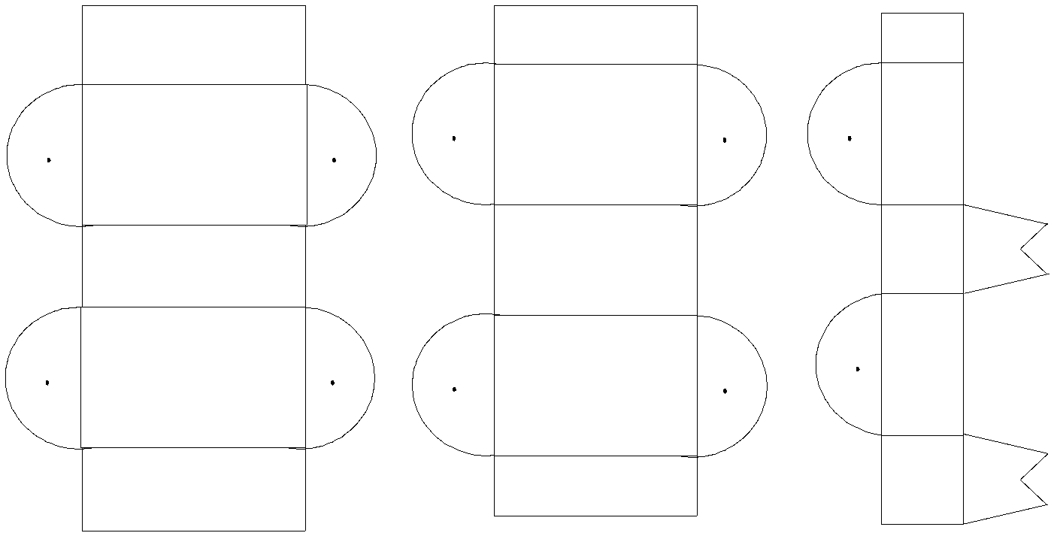

Humerus

Radius/ulna

Carpal

